

PROJECT REPORT
EXPERIENTIAL ENTREPRENEURSHIP 1
CHECK POINT 4

MealMate AI

Lecturer: Le Hoang Anh
Group name: Group 1
- Luong Duc Hung HE190143
- Nguyen Manh Quyen HE180285
- Vu Cong Boi HE180159
- Do Khanh Linh HS186627
- Le Anh Chien HS186663
- Nguyen Nhat Minh HE161060

Table Of Contents

A. Introduction 4
I. Project Overview 4
II. Project objectives 4
III. Overview of MealMate AI 4
B. Team structure and organization 4
I. Introducing the team 4
II. Organizational structure 5
III. Roles and responsibilities of members 5
C. Market Context and Customer Pain Points 6
I. Difficulties in Decision-Making and Meal Planning 6
II. Food Waste and Financial Burden 6
III. Market Gap: The Shortcomings of Current Solutions 6
D. Technological Solution: MealMate AI 6
I. Product Overview 6
II. Value Propositions 7
III. Key Features 7
IV. The Product/Market Fit Canvas 7
E. Market Analysis 9
I. Market Overview 9
II. Changes in lifestyle and cooking habits 9
III. Market size (TAM – SAM – SOM) 10
F. Competitive Analysis 11
I. Competitors 11
II. Analysis 11
III. SWOT analysis 13
G. Customer Research 15
I. Survey analysis 15
II. Details from the interview. 22
III. Customer details 25
H. Target Customers 26
I. Character 1 – A student living away from home 26
II. Persona 2 – Young people who are working 27
I. Customer Journey 28
I. Pre-purchase phase 31
II. Purchasing phase 31
III. Post-purchase phase 31
J. Business Model Canvas 31
K. Financial Plan 36
I. Development Cost 36
II. Fixed costs 37
III. Variable Cost 38
IV. Contribution Margin 39
V. Break-even analysis 40
L. Investor Evaluation Criteria 41
I. Management Team Criteria 41
II. Business & Deal Criteria 42
III. Product/Service Criteria 43
IV. Financial criteria 44
V. Market Criteria 44
VI. Investor Criteria 45

A. Introduction

Project Overview
MealMate AI is a project to build a cooking support tool via website/app, carried out by a group of 6 FPT University students majoring in Artificial Intelligence, Software Engineering, and Marketing. The project focuses on the following features: Scanning ingredient images to suggest dishes and managing expiration dates. Instead of requiring users to manually input data, the system uses computer vision to recognize what the user has available, thereby providing specific cooking instructions.

Project objectives
The project was launched to address three practical issues that the team had surveyed from the student and young working community:
- Food waste: Many people have a habit of stockpiling food but forgetting to use it, leading to expired products. The project aims to help consumers monitor expiration dates to use ingredients more efficiently.
- Daily decision-making pressure: Eliminate the need to spend 15–30 minutes each day just thinking up menus based on the disparate ingredients you have on hand.
- Skills barrier: Support those with no cooking experience by providing simple recipes with clear measurements, making the most of what they have to save on grocery costs.

Overview of MealMate AI
The system is designed to operate in a closed loop process:
- Input: Customers take photos of food (vegetables, fruits, meat, packaged goods).
- Handle: The AI ​​model analyzes images, identifies ingredients, and estimates freshness/shelf life based on user-defined data.
- Output: The system matches ingredient data with a recipe library to suggest the most feasible dishes in a short amount of time (approximately 30 seconds).
- Additional support: The system reminds you to add to the shopping list if you're missing any essential spices to complete the dish.

B. Team structure and organization

Introducing the team
The team consists of members whose expertise directly supports the technical product. A common characteristic of the group is their understanding of the living habits of students in major cities like Hanoi and Ho Chi Minh City – the main target group of the project.
- Technology Team (4 members): Responsible for everything from training AI models to building user interfaces.
- Operations & Marketing Team (2 members): Responsible for conducting on-site surveys, calculating costs, and finding the most effective ways to reach users within a low budget.

Organizational structure
The team operates using a flat hierarchy to suit the scale of the student project:
- Direct communication: Every member has the right to contribute ideas to all stages, from technical aspects to brand imagery. This helps to speed up the product refinement process (Iterative development).
- Division by specialization: Despite working flexibly, each individual still plays the final, crucial role in their respective field to ensure that the quality of work does not overlap.
- Lean model: The team prioritized creating a full version (MVP) as early as possible to gauge user feedback, rather than focusing too long on perfecting every feature at once.

Roles and responsibilities of members
Member | Job title | Primary responsibility
Luong Duc Hung | CEO | Finalize decisions regarding product features; coordinate progress between the AI ​​team and the Marketing team; be accountable for the project's final outcome to the expert panel.
Nguyen Manh Quyen | CTO | Core technical responsibilities include: training image recognition models, developing algorithms for filtering food recipes, and managing food databases.
Vu Cong Boi | COO | Manage data labeling processes for AI; monitor system performance and coordinate internal collaboration.
Nguyen Nhat Minh | CCO | Design the user flow diagram and application interface to be as simple as possible, minimizing the number of steps from the moment the computer starts up until the formula is displayed.
Le Anh Chien | CMO | Conduct real-world user surveys; manage free promotional channels (TikTok, Facebook Groups) and translate customer needs into requirements for the technical team.
Do Khanh Linh | CFO | Control server rental costs, calculate the product's cost if commercialized, and plan the budget for subsequent development phases.

C. Market Context and Customer Pain Points

Difficulties in Decision-Making and Meal Planning
Decision Fatigue: The question "What to eat today?" seems simple but is a daily psychological pressure. After a long, stressful day of studying or working, having to think of a menu, check the fridge for leftovers, and then start cooking discourages many people.
Time and Skill Barriers:
- Students: Often lack diverse cooking skills and don't know how to combine random, leftover ingredients in their rooms into a complete meal.
- Young Professionals: Have a very tight time budget. They want to eat home-cooked meals for health and savings but lack the time to plan, leading them to compromise by ordering food delivery.

Food Waste and Financial Burden
The "Forgotten in the Fridge" Reality: Unplanned or bulk shopping habits often result in ingredients being pushed to the back of the fridge and forgotten until they spoil or mold.
Invisible Financial Burden: Throwing away spoiled food is not just an environmental issue but a direct waste of money. For students and young professionals on a tight budget, the monthly accumulated cost of wasted food is a significant financial leak.

Market Gap: The Shortcomings of Current Solutions
Limitations of Existing Solutions: Current recipe platforms (like Cookpad, YouTube) only solve a "one-way" problem: You must already know what you want to cook before searching for the recipe. They fail to solve the real-world dilemma: "I only have these specific ingredients (half a cabbage, 2 eggs), what is the fastest dish I can make?"
Conclusion: The market lacks a proactive "assistant" capable of analyzing what users currently have and making quick decisions for them, helping them save time while optimizing their grocery budget.

D. Technological Solution: MealMate AI

Product Overview
MealMate AI is not a standard recipe search application; it is a Smart Cooking Decision Assistant.
The product utilizes Artificial Intelligence (AI) and Computer Vision to bridge the gap between the available ingredients in the fridge and a complete meal, helping users answer the daily question "What to eat today?" in just a short amount of time.

Value Propositions
Reduce Decision Fatigue: Transforms meal planning from a tedious, tiring task into a fast and enjoyable experience.
Maximize Time Savings: Eliminates the need for manual searching; the entire process from ingredient recognition to menu planning is fully automated.
Minimize Waste & Save Money: Optimizes the use of existing ingredients, specifically prioritizing items that are nearing their expiration dates, thereby protecting the user's wallet.

Key Features
AI Ingredient Recognition (The "Unique Value Propositione"): Customers simply need to take a photo of the ingredients on their counter or in the fridge. The AI will automatically scan, accurately identify the food items, and estimate quantities.
Smart Suggestions: Based on the scanned ingredients, the system instantly recommends the most viable recipes. The algorithm learns from the user's taste preferences and cooking history to personalize these suggestions over time.
Smart Expiration Alerts: The application tracks storage duration and sends notifications when food is about to spoil (e.g., "Your beef is expiring soon, try making a beef and celery stir-fry tonight!").
Nutritional Meal Planning (Premium Feature): Allows users to set specific dietary goals (weight loss, eat clean, etc.) so the AI can automatically generate a weekly menu and export the necessary grocery shopping list.

The Product/Market Fit Canvas

1. Customer Segment
Characteristics & Jobs-to-be-done
- Target Audience: Busy urban households, fitness enthusiasts (Gym/Keto), and caregivers for children or the elderly.
- Jobs to be Done: Efficiently managing home food inventory, planning science-based personalized nutrition, and optimizing daily cooking workflows.
Problems & Needs
- Pain Points: High food waste (8 million tons/year in Vietnam), financial loss (~2% GDP), and "decision fatigue" regarding daily meals.
- Needs: A solution to digitize inventory without manual entry and to balance nutritional macros (Protein, Carbs, Fat) for various family members.
Channel
- Direct: Mobile application (iOS/Android) and direct integration with Smart Fridge IoT operating systems.
- Indirect: Green living/Eat Clean communities and retail partnerships (WinMart, Co.op Mart, GrabMart).
User Experience
- Action: 5-second "Multi-capture" photo digitization and instant menu matching based on available ingredients.
- Value Received: A sense of total control over the kitchen, reduction in "eco-guilt" from wasting food, and personalized wellness tracking.

2. Product or Service
Alternatives
- Traditional Methods: Manual paper notes, generic note-taking apps (Keep/Evernote), or passive recipe apps that do not track inventory.
- Behavioral: Instinctive "impulse" grocery shopping without a planned list.
Key Features
- AI Computer Vision: Automatic multi-object identification and classification of ingredients.
- Biological FIFO: Perishability management algorithm prioritizing ingredients at high risk of spoiling.
- Hyper-Personalization: AI-driven meal plans tailored to specific diets (Keto, Vegan, Muscle Gain) and user skill levels.
Value for the Channel
- Retail: Demand forecasting & automated recurring orders.
- IoT: Enhancing hardware utility with a smart ecosystem.
- Community: Quantifiable eco-impact reports.
- Environment: Methane reduction for Net Zero goals.
Key Metrics
- Impact: Kgs of food saved & Landfill diversion %.
- Product: AI accuracy & App stickiness (DAU/MAU).
- Business: Order conversion rate for partners & User retention rate.

E. Market Analysis

Market Overview
Amidst busy urban lifestyles, rising living costs, and increasing health awareness, the demand for solutions to support meal management and home cooking is growing rapidly. The market for meal planning apps and related food-related technology solutions is emerging as a crucial segment within the global FoodTech and HealthTech ecosystem.
Solution MealMateAI – A smart cooking assistant that uses images of ingredients. The solution is located at the intersection of intellectual development Artificial intelligence (AI) personalizes the user experience, promotes healthy eating, and optimizes living expenses. According to market research reports, the global meal planning market is valued at approximately $1.3 billion in 2024 and expected to reach $5 billion by 2035, with a CAGR of approximately 13%. On a broader scale, the market for meal support solutions (meal planning, nutrition management, smart shopping lists) is growing larger. $13 billion by 2025 and can reach nearly $40 billion by 2035.
In this context, MealMateAI positioned within the FoodTech sector, focusing on meal planning, home ingredient management, food waste reduction, and menu personalization, shows significant potential for growth and scalability.

Changes in lifestyle and cooking habits
Urban youth, including students and young working professionals, face a fast-paced lifestyle, limited time, and the pressure of living expenses. This leads them to cook at home to save money, but they prioritize convenience and minimize the need for complex planning.
Lack of time and cooking experience results in impulsive grocery purchases, inefficient use of ingredients, and waste. The most common pain point is “not knowing what to cook,” even when they have the ingredients readily available in the kitchen.
Simultaneously, smartphones and AI are increasingly playing the role of “personal assistants” in daily life, making users familiar with and trusting intelligent, personalized recommendation systems that support quick decision-making based on habits.
The development of AI-driven meal planning, with a higher growth rate than traditional solutions (estimated CAGR of over 20%), allows for reduced cognitive effort, personalized menus, and optimized ingredient usage. Solutions combining Computer Vision (ingredient recognition from images) and AI-powered meal suggestions, such as MealMateAI, not only directly address the core pain point of users but also expand the market to groups that previously rarely cooked.

Market size (TAM – SAM – SOM)

TAM – Total Addressable Market
TAM represents the entire market that a product can serve in the long term, if not limited by geographical factors, user segments, or deployment resources. In this case, TAM is defined as the FoodTech and Meal Planning market.
On a broad scale, this includes a group of consumers who cook at home, are interested in healthy eating, optimizing living costs, and reducing food waste.
This market encompasses technology solutions supporting food consumption, such as meal planning apps, household ingredient and inventory management, smart shopping recommendations, and platforms promoting sustainable consumption.
The TAM market is considered large and fast-growing, driven by rapid urbanization, increasingly busy lifestyles in major cities, the widespread use of smartphones, and growing consumer awareness of cost savings and sustainability.
TAM reflects the long-term potential of the product and serves as a strategic foundation for future scaling and diversification of services.

SAM – Serviceable Available Market
SAM is the market segment within TAM that a product can practically reach and serve, based on deployment scope, product characteristics, and user needs.
At this stage, SAM focuses primarily on users in large urban areas, including students and busy working professionals, as well as small families of 1–3 people who prefer cooking at home but lack the time to plan meals.
This user group has a clear need for solutions that shorten meal planning and preparation time, manage ingredients efficiently to minimize waste, and optimize living costs. Furthermore, they have a high level of tech acceptance and are willing to pay for useful applications that provide real value in their daily lives.
SAM is considered a segment with appropriate scale and clear commercial potential, acting as a bridge between the long-term vision of the overall market (TAM) and the initial target market (SOM), and serving as a foundation for expansion after the product is validated.

SOM – Serviceable Obtainable Market
SOM is the most realistic market segment that the product can target in the initial phase, aligning with current resources and marketing strategies.
The SOM target group includes students, renters, and those living alone or in small groups in large cities. This group has limited budgets, is price-sensitive, frequently cooks their own meals, and is prone to problems such as overpacking, forgetting about expiring ingredients, and lacking a clear meal plan.
The SOM segment was chosen because it is easily accessible through online channels and social media, willing to experiment with new technology products, and capable of providing quick feedback to improve the product.

F. Competitive Analysis

Competitors
- MealPlan: Vietnamese Localized Content with Calories Control
- CookPad: The Currently Best Localized Culinary Content
- Pestle: The Premium UX & Productivity Standard

Analysis
Item description | Competitor 1:  MealPlan.vn | Competitor 2:  CookPad | Competitor 3:  Pestle
These three brands are selected because they represent the Vietnamese Website for Calories Control (MealPlan), localized culinary content (Cookpad), and premium meal-planning experience (Pestle), collectively forming the perfect strategic blueprint for your AI-powered solution.
PRODUCT | A specialized Vietnamese platform providing structured meal plans. Key features include curated weekly menus (Clean Eating, Keto, Weight Loss), automated grocery lists with precise measurements, detailed nutritional breakdowns (Calories, Macros) and focuses on "Outcome-based Eating" rather than just recipe discovery. | A Customer-Generated Content (UGC) social network for cooking. In Vietnam, it is the largest repository of localized "home-style" recipes submitted by real local users. | A premium "Personal Recipe Organizer." It features a sophisticated "Scraper" to extract data from any URL and a Meal Calendar to schedule weekly cooking.
PRICE | Subscription-based model. While offering limited free trials, the full experience costs 297,000 VND/month. This price point is positioned as an affordable "Digital Nutritionist" for urban office workers and health-conscious youth | Freemium. Basic access is free. Cookpad Premium (approx. 40,000 - 55,000 VND/month) allows users to sort by "Most Popular" (verified recipes) and access AI-assisted search filters. | Paid / SaaS. $1.99/month or a $19.99 Lifetime Pro license. No permanent free tier (limited trial only).
PLACE | Web-app optimized for mobile browsers. It focuses exclusively on the Vietnamese market, specifically targeting Tier 1 cities like Hanoi, Da Nang, and Ho Chi Minh City where the demand for healthy, scheduled eating is highest in 2026. | Mobile-first (iOS/Android). It holds a ~45% market share of the recipe app segment in Vietnam as of early 2026. | Exclusive to the Apple Ecosystem (iOS, iPadOS, macOS). Target demographic: Tech-savvy Gen Z and Millennials with high disposable income.
PROMOTION | Heavily leverages Content Marketing through Facebook "Healthy Living" communities and TikTok influencers in the fitness niche. They utilize "Problem-Solution" advertising, highlighting the pain points of "not knowing what to buy" or "wasting time calculating calories." | Focuses on Community Engagement. They host weekly "Home Cook Challenges" and partner with FMCG brands like Maggi and Knorr for sponsored localized content. | Primarily through App Store Optimization (ASO) and being featured as "App of the Day." Leveraged by Tech-Influencers on YouTube focusing on "Digital Minimalism."
ADVANTAGES | Ultra-localized: Menus feature traditional Vietnamese ingredients and flavors; High Utility: Saves significant time by automating the shopping list; Goal-oriented: Directly helps users achieve specific health results (e.g., losing 2kg in a month). | Deeply localized content; recipes use ingredients easily found in Vietnamese traditional markets; high user trust and social proof. | World-class UI/UX; Hands-free Voice Control for cooking; seamless integration with Apple Reminders for grocery shopping.
DISADVANTAGES | Static Input: Customers must follow a pre-set plan; it lacks AI Vision to suggest meals based on what the user already has in the fridge; Low Flexibility: If a user misses a day or lacks an ingredient, the system does not automatically re-adjust the plan in real-time. The entire process, from AI assistance to meal planning, has not yet been fully integrated. | Manual Search-based UX; lacks automated meal planning; no AI image recognition—users must still browse through thousands of static posts. The entire process, from AI assistance to meal planning, has not yet been fully integrated. | Platform Restriction (ignores 60% of the Vietnamese Android market); high price barrier for students; no "suggestive" AI—users must find their own recipes first. The entire process, from AI assistance to meal planning, has not yet been fully integrated.

SWOT analysis

Strengths
Understanding the eating habits and thrifty mindset of Vietnamese users: Based on real users, the team understands the daily shopping and cooking habits of Vietnamese people. They understand that Vietnamese people prioritize home-cooked meals, tend to stock up on food in their refrigerators, and always want to reuse leftovers to save money and avoid food waste. This practical understanding helped the project stay on the right track from the start: focusing on solving the basic needs of daily life and avoiding creating unrealistic technological features that nobody would use.
The team combines all the necessary elements to realize the project, ensuring its feasibility through a clear and complementary division of roles. The team consists of three AI members responsible for the core technology: ingredient recognition, expiration date classification, and recalculating cooking plans. A Software Engineer member is responsible for building the web or app so the system can run on mobile devices. Meanwhile, two Marketing members handle the financial calculations and how to get the product to consumers, ensuring the project is not only technically sound but also commercially viable.
Along with the ability to create resource-optimized and authentic products, the team is confident in building a practical application. The application will focus on prioritizing the use of products that are about to spoil to avoid waste, while suggesting dishes that are authentically Vietnamese and tailored to individual tastes. Furthermore, the team has the capability to develop intelligent features that suggest purchasing the exact spices needed and filter out quick recipes suitable for busy lifestyles.

Weaknesses
The risk lies in the technical structure, specifically the personnel structure. There are three people working on the AI ​​brains, but only one person is responsible for the framework (Software Engineer), who handles server setup, API writing, Android/iOS app development, and security. This poses a serious structural risk: if this person falls ill or leaves, the project could be paralyzed because there's no one to replace them and bring the AI ​​system to users.
The risks in finding "clean data" that the AI ​​team cannot process on its own: Despite having three AI members skilled in algorithms, the biggest weakness is the complete lack of raw data. For the AI ​​to become intelligent, it needs to "consume" thousands of photos of Vietnamese food from various angles and lighting conditions. With only six people, the team lacks the manpower to take photos in real markets/supermarkets or manually label tens of thousands of images. This leads to the risk that the AI ​​will work well on the team's computer (an ideal environment), but when users take blurry/dark photos in real life, the AI ​​will either fail or make completely inaccurate identifications.
Limited investment capital hinders operation and expansion: As a small-scale, self-initiated project, the team faces the challenge of "zero funding." Regarding infrastructure: Without the funds to rent high-end GPUs (expensive cloud servers), the team has to use free/cheap packages, resulting in very slow app performance (lag) when processing images, causing frustration for users. Regarding marketing: Despite having two marketers, the lack of an advertising budget forces the team to rely on manual labor to create viral content. This leads to very slow user reach and risks the project failing before it has enough users to generate revenue.

Opportunities
Socio-economic trends: The rising cost of eating out in Vietnam in 2026 is making home cooking a necessary cost-saving solution for many people. MealMate AI is the tool that helps them achieve this most effectively. This key Gen Z customer group is entering the stage of starting families but lacks traditional cooking skills. They crave technological solutions that can guide them step-by-step.
Technological infrastructure development: The government is promoting the digitalization of retail. When supermarkets issue electronic invoices directly to email/phone numbers, MealMate AI has the opportunity to synchronize data instantly without users needing to scan manually.
Partnership opportunities: The chance to collaborate with retail chains (WinMart, Lotte) on promotional programs like "Recommended Dishes - Discounted Ingredients".
Health niche market: The ability to expand into personalized meal plans based on nutritional regimens (Eat Clean, Keto, calorie counting) allows the application to reach a wider range of user groups.

Threats
Customer patience threshold: This is a critical challenge. If the recognition technology (OCR & AI Vision) doesn't achieve an accuracy rate above 90% or the receipt scanning process takes too long, users will quickly revert to their habit of "remembering by head." An inadequately streamlined UX design will turn the application into a burden instead of a convenience.
The unique characteristics of "traditional markets" in Vietnam: A large segment of the population still maintains the habit of shopping at traditional markets – where food lacks barcodes and receipts and is often packaged in colored plastic bags. Accurately identifying specific herbs and spices hidden in low-light conditions is a "heavyweight" technical challenge requiring significant R&D resources.
The diversity and complexity of regional cuisine: Vietnamese tastes are very discerning and deeply differentiated across the North, Central, and South. Recommendation algorithms would be considered "useless" without understanding the subtleties of local spices or traditional units of measurement (such as bunches, handfuls, and ounces). Building a "standard Vietnamese" food dataset is a significant challenge in terms of both time and cost.
AI legal risks and liability: Regulations regarding AI accountability and personal data protection in Vietnam will become increasingly stringent. Any errors in warning about expiration dates or suggesting allergens could lead to serious legal problems and completely shatter user trust in the brand.

G. Customer Research

Survey analysis

Demographics
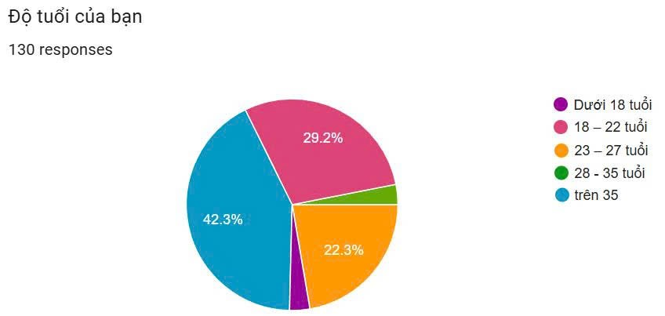
A survey of 130 participants revealed that MealMate AI's target user group is primarily young people, with 93.8% under 27 years old. Students and university graduates make up the largest proportion, approximately 65%, while the remainder are young working professionals and some small families. A notable commonality among this group lies not in their occupation or income, but in their living circumstances: the majority live far from their families and must make their own daily meal decisions.
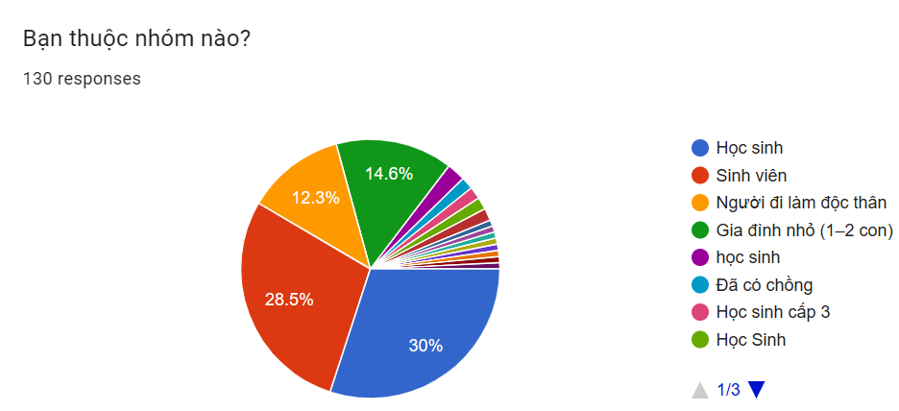
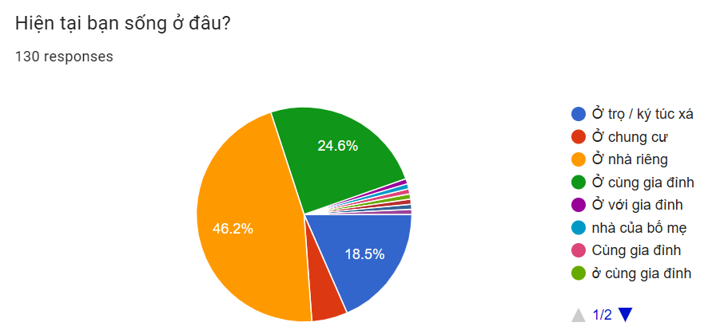
In the transitional phase from being cared for to becoming independent, this user group has not yet formed stable eating habits. They no longer have someone to "cook for them," but they also lack the experience, skills, and support systems to proactively manage their meals. This is the underlying context that creates the cooking and decision-making challenges that MealMate AI aims to address.

Eating and Cooking Behavior – Reality is Different from Belief
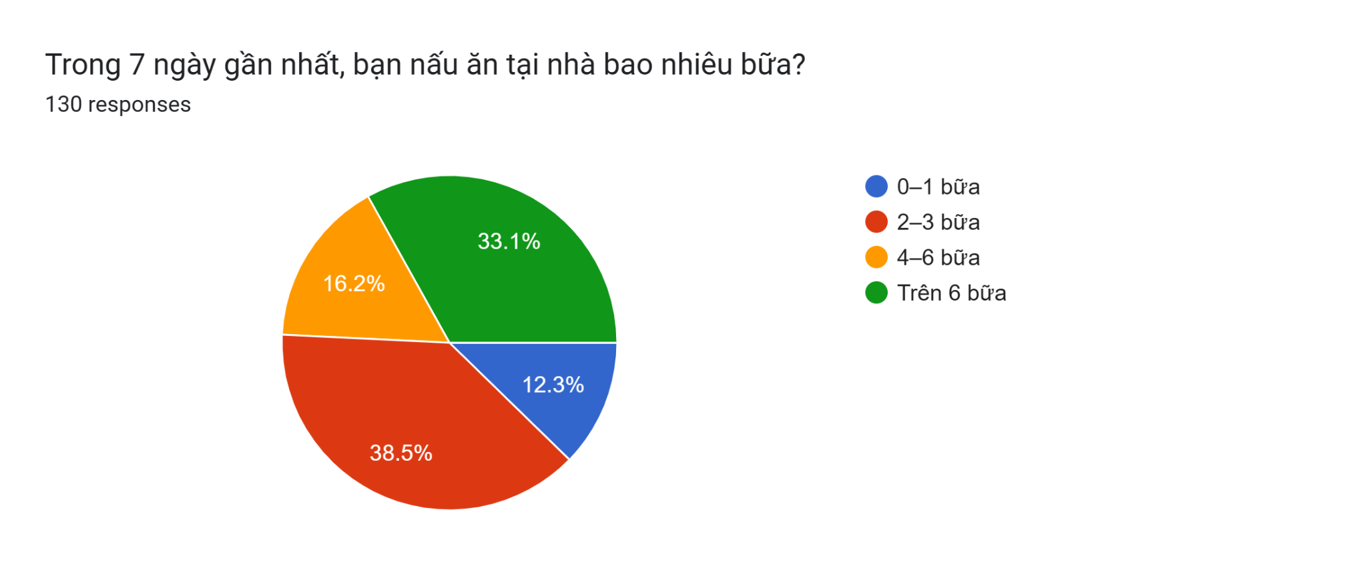
Behavioral analysis reveals that the stereotype of "young people being lazy cooks" doesn't accurately reflect reality. As many as 87.7% of survey participants reported cooking at home at least two meals a week, with 33.1% cooking more than six meals a week. This demonstrates that cooking remains a familiar part of their daily lives.
However, cooking is not a regular or planned activity. Many people cook passively, depending on their free time, leftover ingredients, or momentary inspiration. This makes cooking a mentally exhausting activity, rather than an organized and optimized habit.
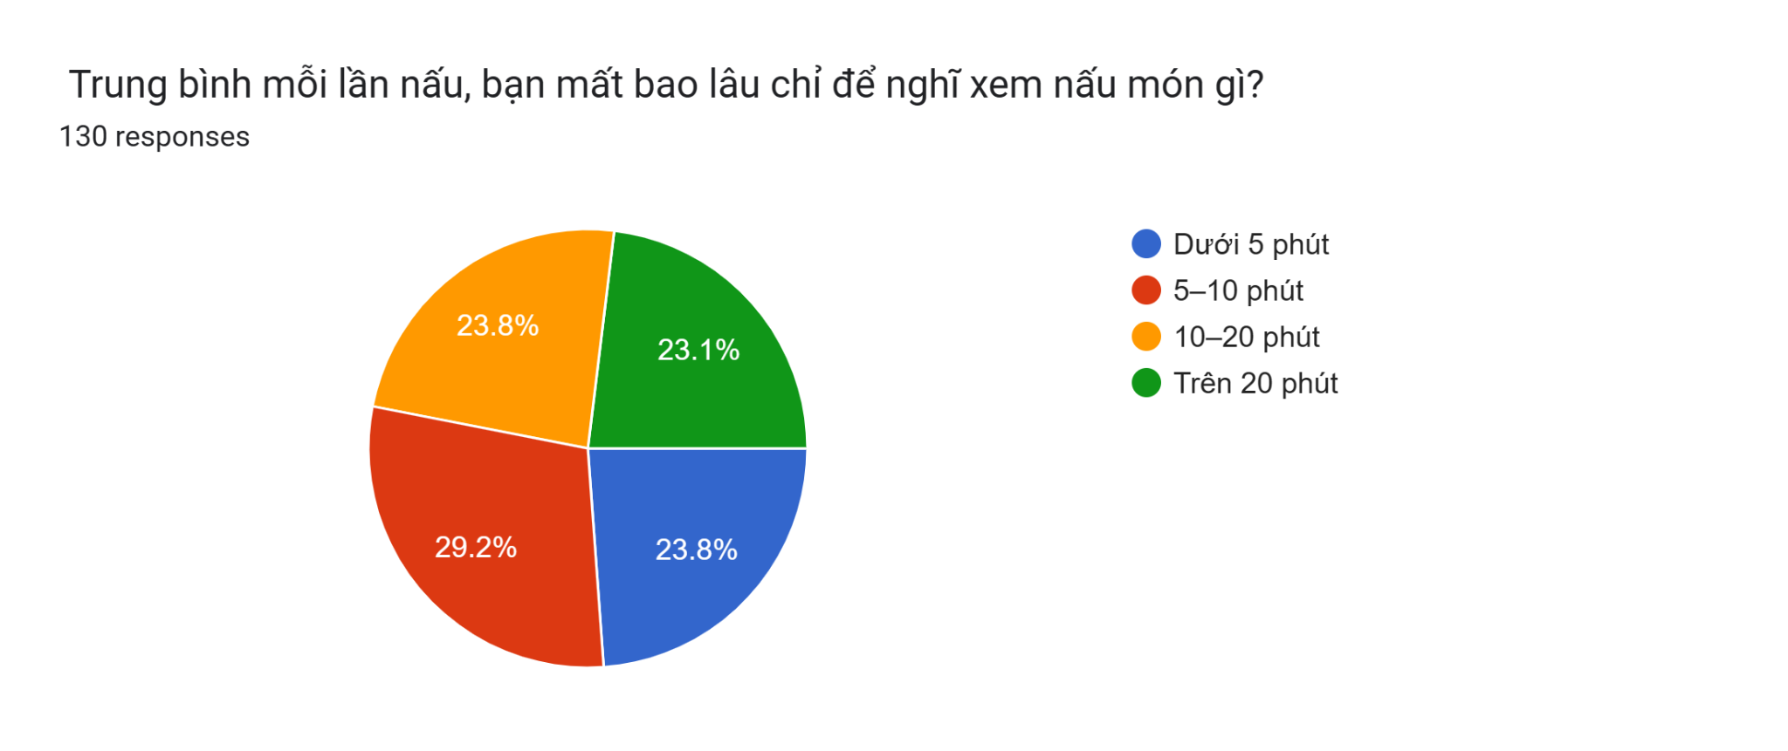
A key indicator reflecting this is the amount of time users spend just thinking about what to cook today. As many as 76.1% spend more than 5 minutes, with nearly half spending more than 10 minutes, and even 23.1% spending over 20 minutes on decision-making. This time doesn't create direct value but is repeated daily, gradually becoming a psychological burden.

Pain points
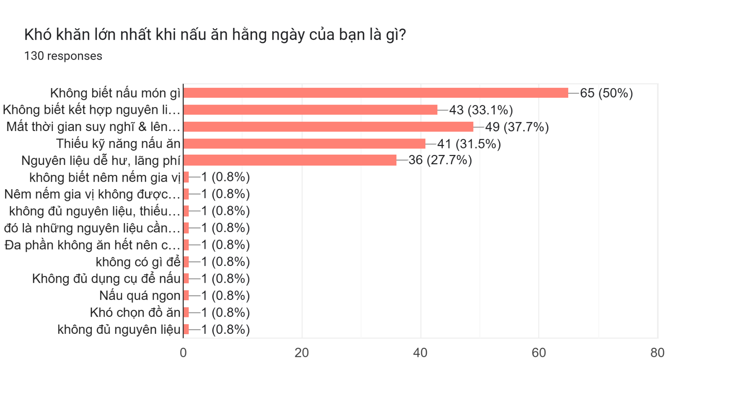
When delving into the difficulties in cooking, the survey results revealed that the core issue wasn't a lack of skill or not knowing how to cook. The most frequently chosen difficulties related to not knowing what to cook today, not knowing how to combine available ingredients, and spending too much time thinking and deciding.
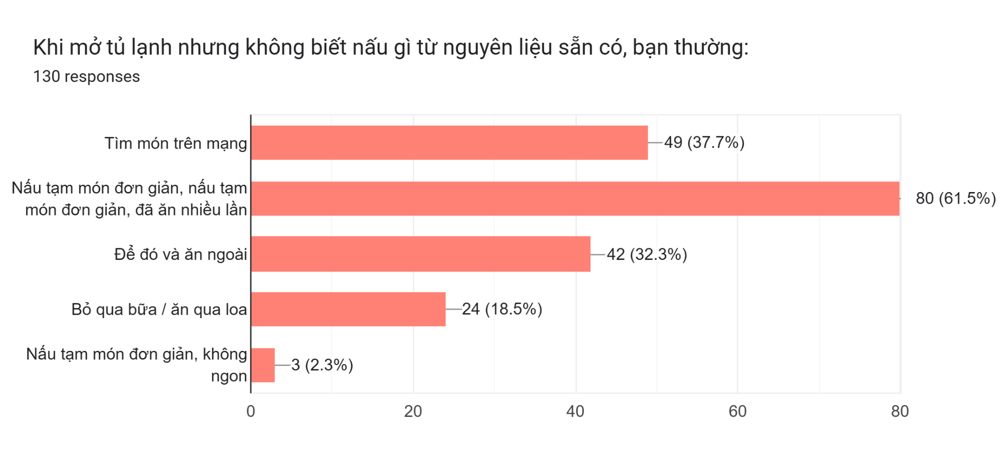
This reveals that the biggest pain point for users is "decision fatigue"—the exhaustion from constantly making small, repetitive decisions every day. Cooking is no longer a technical issue, but a psychological and cognitive one. When unable to make quick and confident decisions, users tend to choose a less mentally demanding alternative, even knowing that it's not the optimal choice.
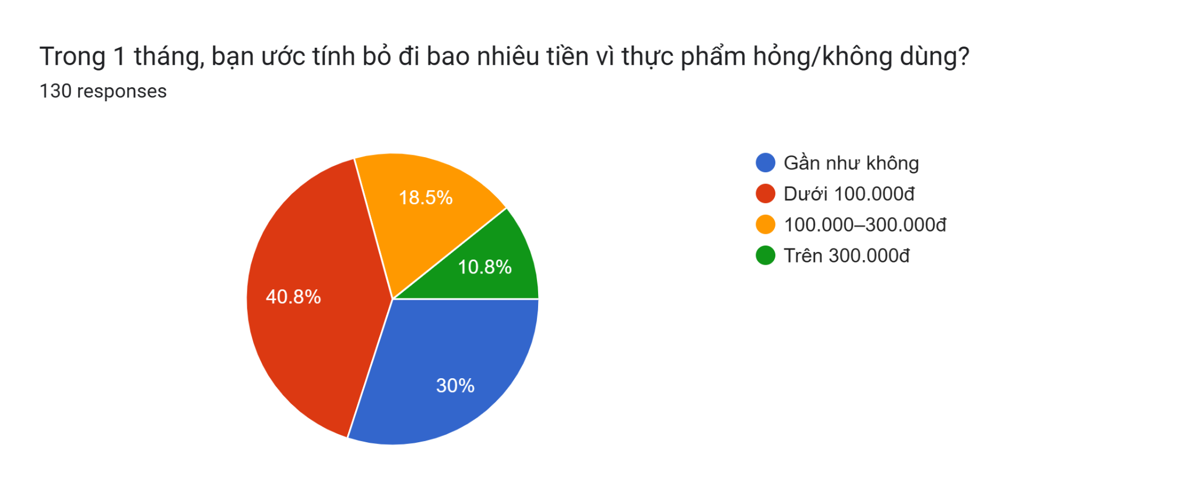
The direct consequence of this pain point is reflected in the level of food waste. 29.3% of participants reported wasting over 100,000 VND per month on leftover food. Waste here isn't just about money; it also represents a feeling of failure in controlling one's meals and personal habits.

Perceptions and how users interpret problems
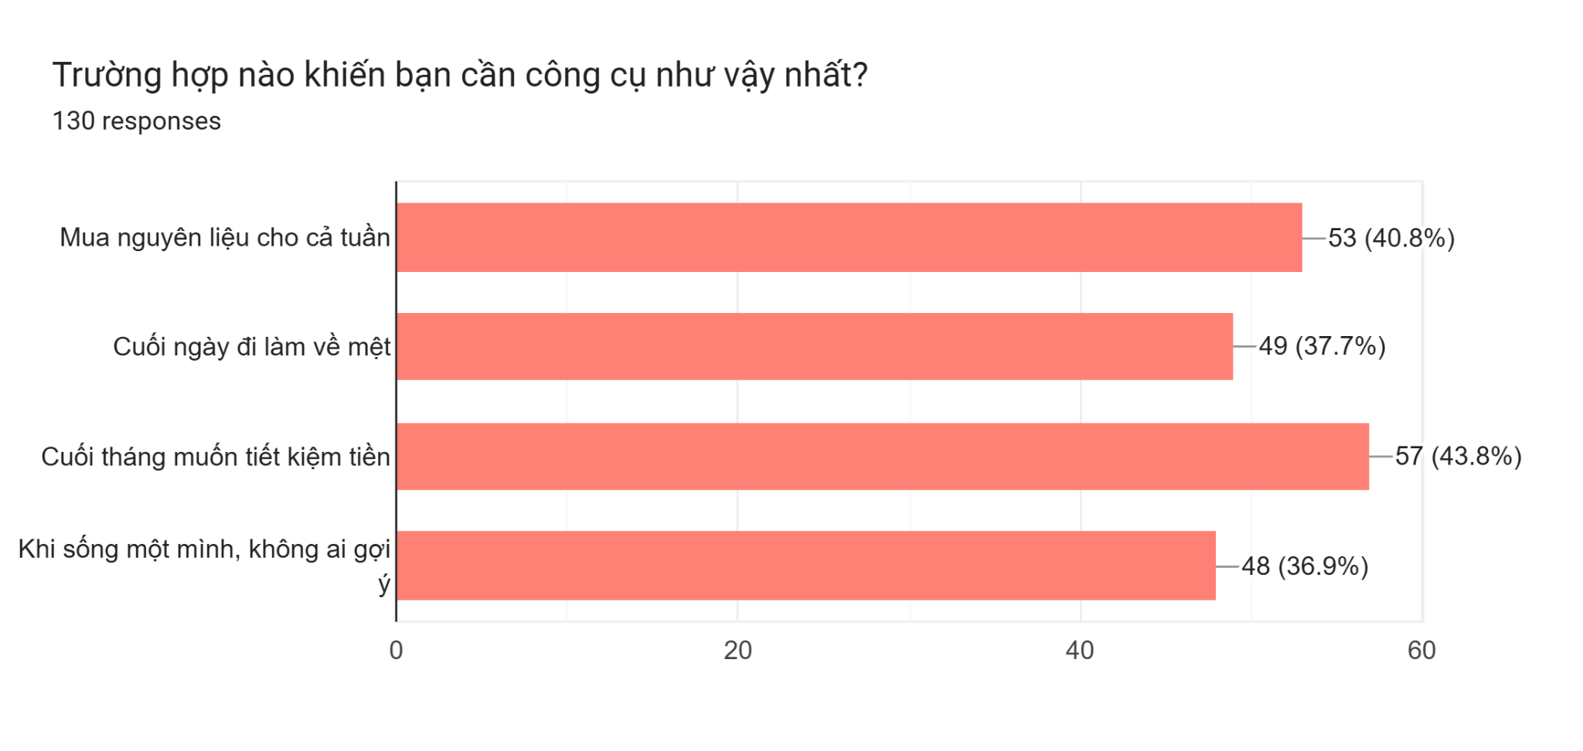
A notable finding in the survey is that users are very aware of their own problems. In their open-ended responses, they frequently mentioned "wasting time thinking of what to cook," "opening the refrigerator but not knowing what to cook," and "ending up eating out for a quick meal." This shows that they are not denying or avoiding the problem, but are fully aware of the reasons why their cooking experience is negative.
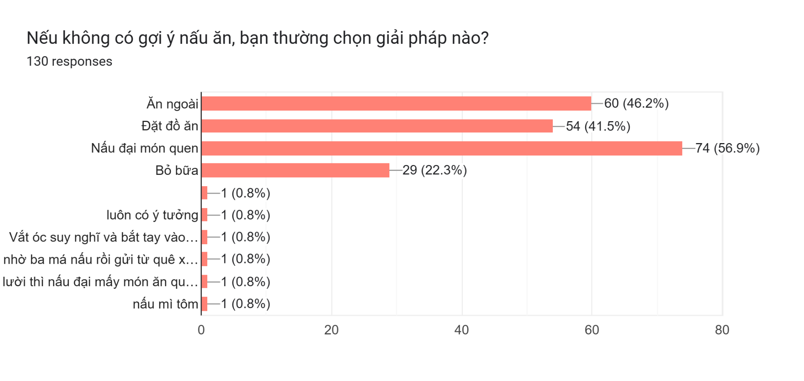
However, users' self-explanatory responses to the problem are often personal, such as attributing it to laziness, a lack of discipline, or poor cooking skills. In reality, data suggests the problem is more systemic than personal. Customers are lacking a decision-making tool tailored to their specific circumstances, rather than a lack of motivation or knowledge.
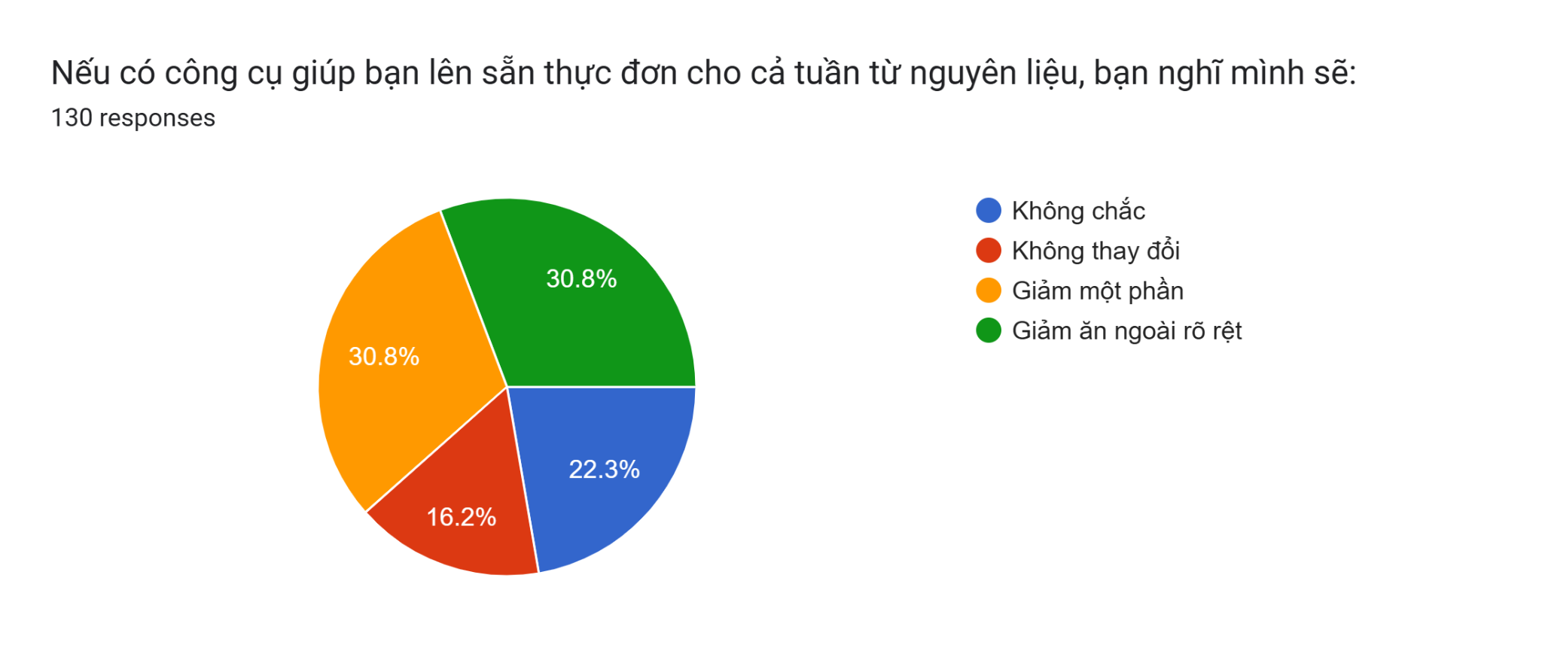
It is this disconnect between the true cause and how users interpret it that leads them to accept the current situation, instead of seeking a more radical solution.

Behavior regarding the use of tools and technology
When unsure what to cook with available ingredients, users often turn to familiar tools like Google, TikTok, or YouTube. These platforms offer a wealth of content, but lack personalization tailored to each user's specific context, such as available time, ingredient quantities, or dietary goals.

Therefore, instead of reducing the burden of decision-making, current tools sometimes exacerbate the problem by forcing users to choose between too many options. This prolongs the decision-making process and easily leads to giving up halfway through.
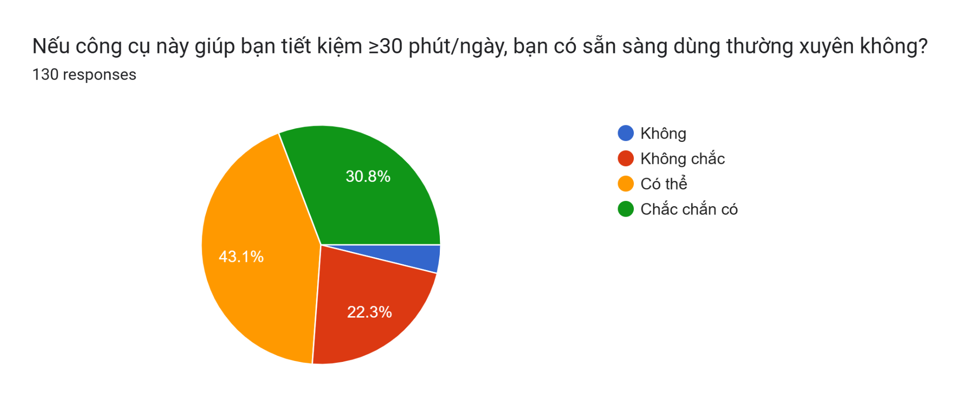
Nevertheless, user attitudes towards technology are very positive. As many as 73.9% said they would be willing to use an AI assistant if it saved them at least 30 minutes a day. This shows that users are not afraid of technology, but are simply waiting for a truly useful and suitable solution.

Motivation & Values
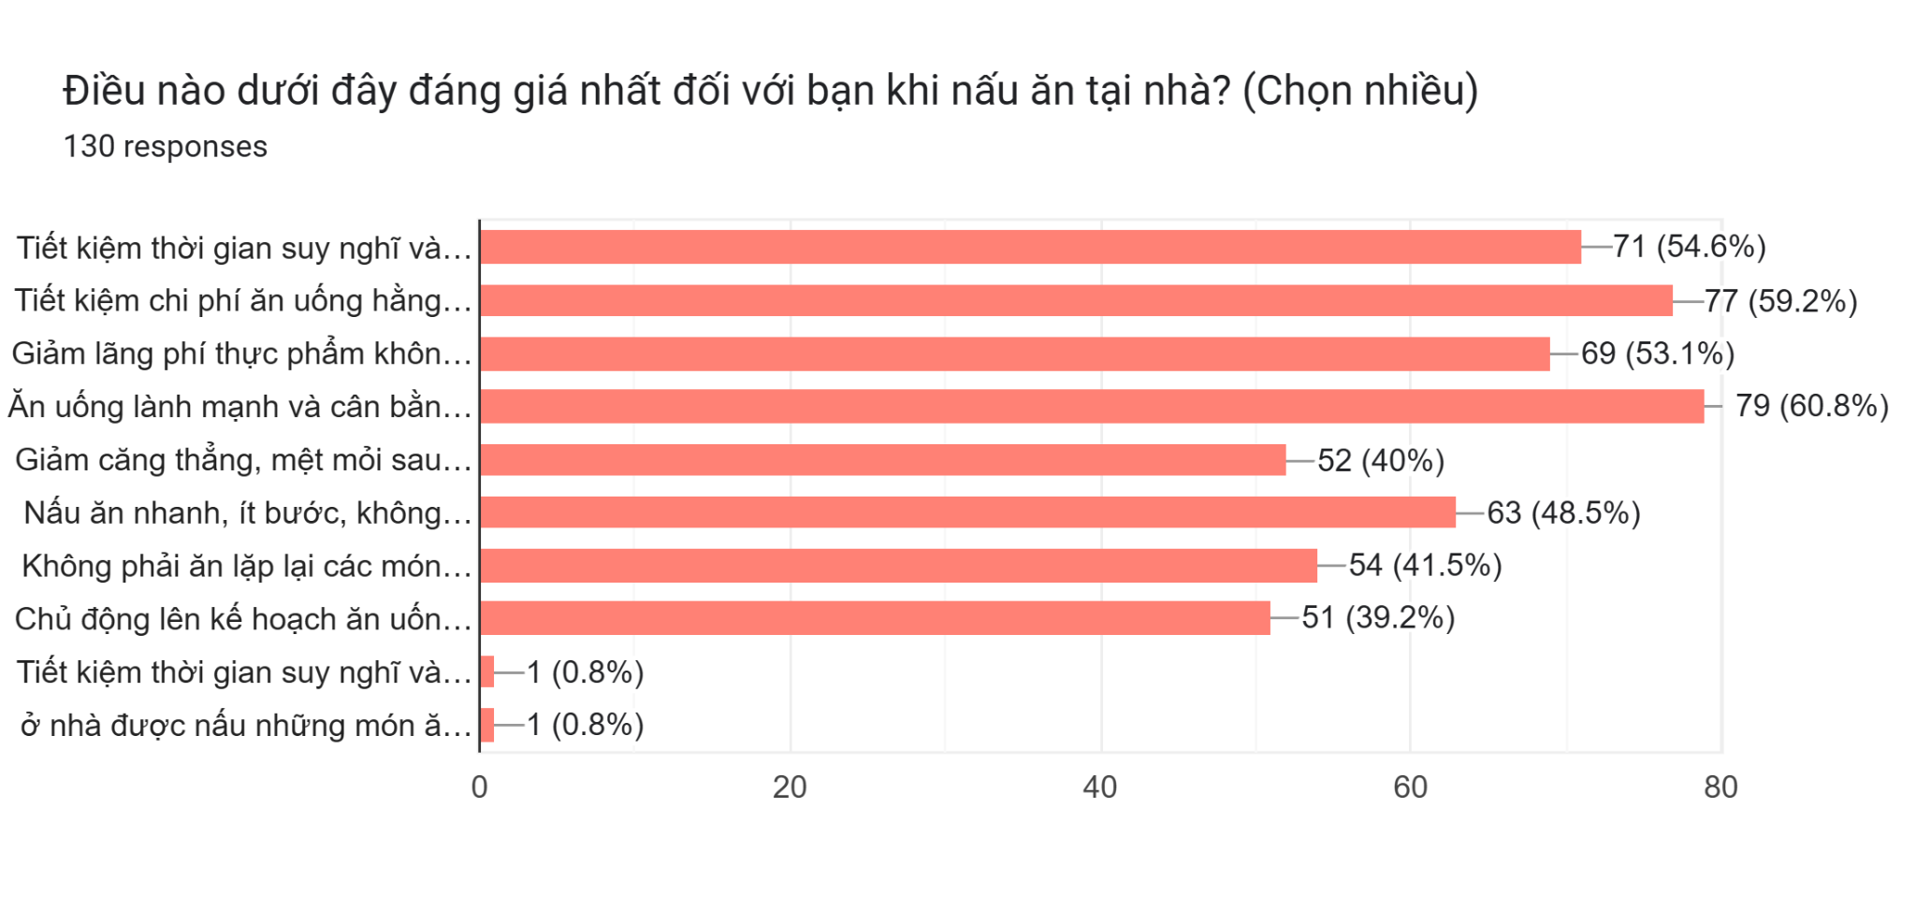
When considering the values ​​consumers prioritize in cooking, the top priority isn't delicious or healthy food, but rather saving time and effort. Saving decision-making time, reducing food waste, and saving costs are the main motivations.
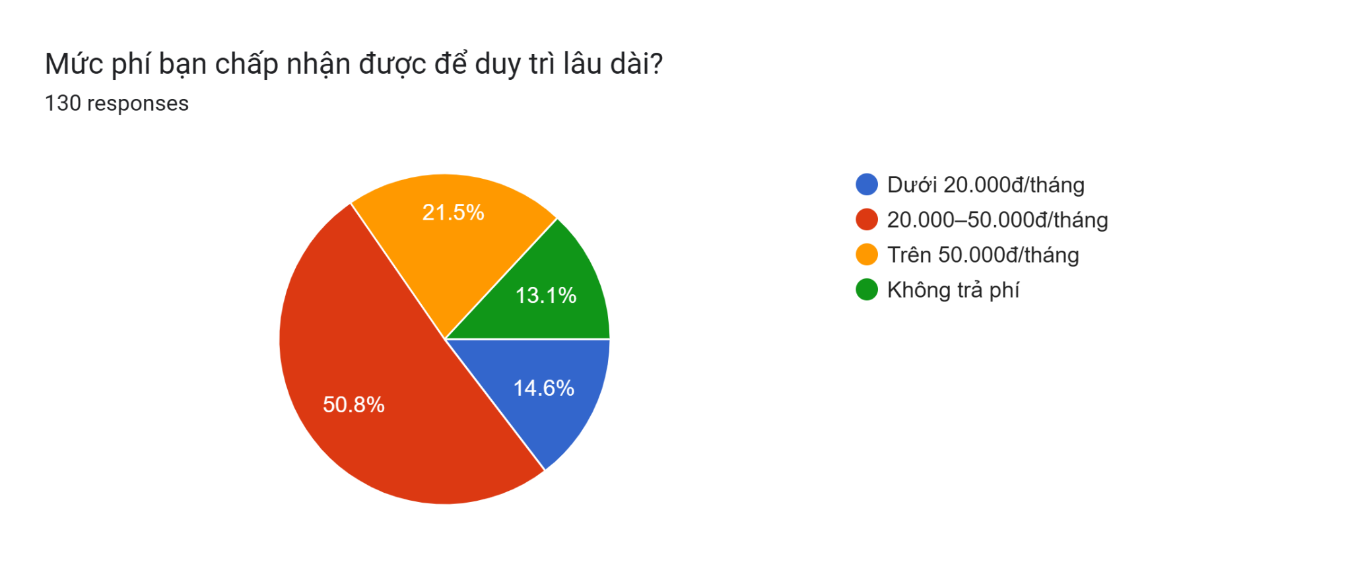
This reflects a very real need: users want cooking to be "less stressful." Healthy eating or improving cooking skills only becomes important once the burden of the initial decision has been resolved. This is also why 72.3% of survey participants are willing to pay a minimum of 20,000 VND per month for a suitable solution.

Details from the interview.

Interview context & target audience
All seven interviewees were students living away from home, aged 19-23, studying at universities in major cities, specifically Hanoi. Their biggest commonality was that they had to take responsibility for their daily meals, whereas previously they were accustomed to having their meals prepared by their families.
Despite their differing living circumstances (living alone, renting, sharing with friends), all seven individuals exhibited erratic eating habits, making quick, hasty meal decisions that were more situational and emotional than long-term planned.
From this, it can be seen that this group of people are not indifferent to eating, but rather lack the mental energy to manage it every day.

Practical eating and cooking behaviors
Through interviews, it can be seen that: “Cooking at home is not a sustainable habit of the participants”. Although most were capable of cooking basic dishes, cooking only took place when favorable conditions were met, such as:
- The ingredients are readily available and easy to use.
- Relaxed state of mind
- Not too busy or tired
Most of the time, they eat out or order takeout, even when there's still food in the refrigerator. This isn't simply laziness, but rather:
- I don't know what to cook with the ingredients I have.
- Feeling that cooking is too complicated and not worth the effort.
- I don't want to have to think about anything else after a tiring day of studying.
Notably, meal decisions are often made quickly, but the consequences (wasted money, unhealthy eating, food waste) leave them dissatisfied later on.
From this, we can see that cooking failure doesn't lie in skill, but in decision-making.

Pain points – The real problems and annoyances
From the interviews, three core pain points can be summarized:
First, it's tiring having to decide what to eat every day.
The question "What should we eat today?" seems simple, but it's a recurring source of stress. Customers don't know where to start, the more they search, the more confused they become, and ultimately they choose the easiest solution: eating out.
Secondly, wasting food comes with feelings of guilt.
Most participants had previously thrown away vegetables, meat, or food sent by their parents because they hadn't used it for too long. This created feelings of regret and guilt towards their family, but not strong enough to change their behavior in the long term.
Third, the existing tools don't address the problem properly.
TikTok, YouTube, and other recipe apps only offer "ideal dishes," without considering what users actually have in their refrigerators, leaving them wanting to watch but ultimately not cook.
From this, we can see that the biggest pain point is not "not knowing how to cook," but rather not being guided in making decisions based on the current situation.

Perceptions and how users interpret problems
The noteworthy point is that users are very aware of their problem. They know:
- Eating out often is expensive.
- Not cooking food leads to food waste.
- Irregular eating habits are bad for your health.
However, they often explain their failures by external factors such as:
- "Because I'm busy with my studies"
- "Due to an irregular schedule"
- "Because I'm the only one who's lazy, I lack the motivation to cook."
This shows that the problem lies not in awareness, but in the lack of a support system to help translate good intentions into practical action.
From this, it can be seen that users do not need further education; they just need to have their thinking burdens reduced.

Behavior regarding the use of tools and technology
All participants have previously:
- Watch cooking videos on TikTok/YouTube
- Find the recipe on Google or an app.
But nobody continued using it long-term. The main reason is:
- The formula is too complicated.
- Additional ingredients are needed that are not readily available.
- Not personalized to the actual situation.
Conversely, when asked about the idea of ​​photographing ingredients and suggesting dishes, everyone responded positively and said it was "exactly what they needed."
This shows that users are willing to use technology if it solves the problem they are facing in a confusing moment.

Motivation & Values
Four values ​​were repeated throughout the interviews:
- Save money
- Save time
- No need to think
- Avoid wasting ingredients and food.
Health is mentioned, but it's not the main motivation. Customers are willing to eat healthier if it doesn't make them feel more tired.
Regarding payment, users are willing to pay if:
- The tool works correctly.
- Helps reduce eating out.
- Reduce food waste.
Therefore, it's clear that MealMate AI needs to be positioned as a tool for "releasing mental energy," not a cooking app.

Customer details
Through a survey of 130 people, we were able to extract the key insights.
- Young people don't hate cooking; they hate having to figure out what to cook with what they have each day.
- Food waste doesn't come from buying too much, but from not making timely decisions about what to cook.
- When exhausted from studying and daily life, users prioritize options that require the least amount of thought, even if they know those options are expensive and not good for their health.
- Current recipe apps don't make cooking easier for users; instead, they only confuse them because they aren't based on their real-life situations.
- The greatest value consumers seek isn't delicious food or new skills, but the feeling of "mindlessness" when deciding on a meal.
- People living far from family don't lack cooking skills; they lack a tool to help them make quick and correct decisions in moments when they are most tired.
From this, we can see that the core problem for users is not a lack of cooking knowledge or a shortage of cooking ingredients, but rather the burden of having to make daily decisions about what to eat and cook. Therefore, we need to position the product as a tool to help them reduce this thinking burden, acting as a decision-making assistant, helping users know what to cook at that moment, thereby improving eating habits and reducing food waste.

H. Target Customers

Character 1 – A student living away from home
BACKGROUND  - Occupation: University student  - Area: Major city  - Living situation: Living away from home | FINANCE  - Personal income: Below 5,000,000 VND/month (family support)  - Monthly food expense: 1,500,000 - 3,500,000 VND
NEEDS  - Suggestions for what to eat and cook quickly  - Utilize existing ingredients  - Save money, reduce eating out  - Reduce food waste  - Simple recipes with few steps | INFLUENCE FACTORS  - Irregular study and part-time work schedule  - Daily decision fatigue about meals  - Daily energy level and tiredness  - Available ingredients in the fridge  - Convenience over planning  - Social media suggestions
HOPES & DREAMS  - Identify ingredients and suggest suitable dishes immediately.  - Calculate calories and create personalized meal plans.  - Monitor ingredients and alert you to spoilage.  - Suggest and plan meals. | ONLINE BEHAVIOR  - Searches for recipes on TikTok, YouTube, and Google  - Looks for ideas only when stuck  - Rarely sticks to cooking apps long-term  - It often takes a long time to decide.
WHAT MAKES THEIR LIFE EASIER  - Take photos of ingredients → get suitable dish suggestions immediately  - Prioritize dishes that should be cooked first to avoid spoilage  - Quick, accurate, and practical suggestions | WORRIES & FEARS  - Feeling overwhelmed by too many choices when cooking.  - Often eats out even when ingredients are available  - Not knowing what to cook with available ingredients  - Spending too much time deciding what to eat  - Food spoiling and being wasted  - Complicated apps with inaccurate suggestions

Persona 2 – Young people who are working
BACKGROUND  - Occupation: Full-time office worker  - Age: 23–30  - Area: Major city  - Work schedule: Fixed hours but often overtime | FINANCE  - Personal income: 8,000,000 – 15,000,000 VND/month  - Monthly food expense: 2,500,000 – 4,500,000 VND  - Spending behavior: Willing to pay for convenience but still budget-conscious
NEEDS  - Quick meal suggestions after work  - Minimize time spent thinking about meals  - Use available ingredients efficiently  - Reduce frequent food delivery orders  - Simple but nutritious home-cooked meals | INFLUENCE FACTORS  - Long working hours and mental fatigue after work  - Decision fatigue at the end of the day  - Irregular eating schedule  - Limited time and energy to cook  - Convenience and speed are top priorities  - Rising cost of food delivery  - Health concerns from eating out too often
HOPES & DREAMS  - Come home and know immediately what to cook  - Maintain a healthier lifestyle despite busy work  - Save money compared to constant takeout  - Waste less food in the fridge  - Feel more in control of daily life and routines  - Have a “low-brain-effort” cooking routine | ONLINE BEHAVIOR  - Searches for recipes on TikTok, YouTube, and Google  - Uses food delivery apps frequently on busy days  - Downloads apps but abandons them if setup is complex  - Prefers apps that give instant results
WHAT MAKES THEIR LIFE EASIER  - Take photos of ingredients → get suitable dish suggestions immediately  - Prioritize dishes that should be cooked first to avoid spoilage  - Quick, accurate, and practical suggestions | WORRIES & FEARS  - Too tired to think about what to cook after work  - Defaulting to expensive food delivery too often  - Food in the fridge going bad  - Spending too much time deciding what to eat  - Wasting money on unused ingredients  - Food spoiling and being wasted  - Complicated apps with inaccurate suggestions

I. Customer Journey
 | CONSIDER | EXPLORE | COMPARE | TEST | NEGOTIATE | RETENTION | LOYALTY
Durations | - Occurs repeatedly every day  - It may take weeks or months before a solution is found. | - 1–3 days to find a solution  - Can be repeated multiple times | - 1-2 days for consideration  - Occurs immediately after becoming aware of multiple options. | - First 1–3 uses (2-3 days)  - Usually lasts for a few days | - Consider continuing use after 1-2 days.  - It may take longer if it involves payment. | - After 1–2 weeks of consistent use  - Continues over months if the tool becomes part of daily routine | - After 1–3 months of stable usage  - Long-term relationship stage
Customer Actions | - I opened the refrigerator but didn't know what to cook.  - I see the ingredients are readily available, but I lack ideas.  - Asking yourself "what should I eat today?"  - Thinking about the choice between cooking at home or eating out. | - Search for food on TikTok, YouTube, Google  - Watch quick cooking videos  - Read the recipe on the website.  - I started to learn about MealMate AI as a helpful tool. | - Comparison between:  Continue eating out.  + Coming up with dishes based on old habits  + Applying traditional formulas  + MealMate AI  - Consider the level of convenience and speed of decision-making. | - Take photos of the ingredients or enter basic information.  - Receive food suggestions from the system.  - See detailed recipe  - Try cooking according to the suggestions. | - Assess the level of usefulness in daily life.  - Consider long-term use  Consider paying for advanced features. | - Reuse MealMate AI regularly when deciding meals  - Plan meals for several days or a full week  - Track ingredient expiration dates  - Rely on the system before considering eating out  - Explore more features such as meal planning or calorie calculation | - Recommend MealMate AI to friends or roommates  - Share experience on social media  - Mention the tool in conversations when others complain about “what to eat”  - Continue paying for premium features if satisfied
Touchpoints | - Experiencing daily life  - Conversations with friends in similar situations  - Personal pressure after studying/working part-time | - TikTok  - YouTube  - Google  - MealMate AI website | - Applying recipes  - Social media content  - Personal habits  - MealMate AI website | - Ingredient input interface  - Food recommendation system  - Recipe display page | - Price list (if available)  - Long-term benefits information  - Comparing the cost of eating out | - MealMate AI website  - Weekly meal planning feature  - Ingredient tracking and expiration alerts  - Notification or reminder system  - Personal dashboard  - Live chat / chatbot support | - Social media sharing  - Referral programs  - Word-of-mouth conversations  - Community features or student groups
Customer Experience | - Feeling tired after studying/working part-time  - Lack of motivation to think further  - Repetitive daily mental stress  - Aware that eating out is expensive, but without a solution. | - Initially, we hoped to find a quick solution.  - Then I became confused because there were too many options.  - Losing patience when having to filter information. | - Tired of having to compare too many options.  - Feeling overwhelmed by choices  - Easy to give up and revert to old habits. | Curious but reserved  - Expectations suggest a realistic approach.  - If the experience is smooth → relief and satisfaction  - If it's not a good fit → disappointment and leaving. | - Evaluation based on actual value:  + Saves thinking time  + Reduce eating out.  Reduce food waste.  - Willing to pay if the benefits are clear. | - Feeling more organized and in control of meals  - Reduced daily stress about food decisions  - Increased confidence in cooking  - Noticeable savings in food expenses  - Feeling that the tool fits naturally into daily life  - Feeling satisfied and reassured after receiving clear, personalized meal suggestions | - Feeling confident recommending the product  - Viewing MealMate AI as the default solution for meal decisions  - Emotional attachment due to daily usefulness  - Trust in the system’s suggestions
Pain Points | - I don't know where to begin.  - The pressure of making decisions is repeated every day. | - Too many recipes  - Incompatible ingredients  - Lack of personalization | Too many options, but it doesn't help in making a decision.  - Other applications require complex data entry.  - Too many options cause delays. | - Concerns that the suggestions are not realistic.  - The usage process is cumbersome.  - If the first experience isn't good, I'll quit immediately. | - No significant difference has been observed compared to old habits.  - The value is not compelling enough to justify paying the fee. | - Risk of losing interest if suggestions become repetitive  - If the system does not update or improve over time  - Lack of new features such as meal planning or ingredient tracking  - Lack of personalization depth  - Difficulty building a long-term usage habit | - If pricing increases unexpectedly  - If performance becomes unstable  - If competitors offer better personalization  - Low motivation to stay if benefits are similar across competitors
Solutions | - Focus on the question of "what to eat today"  - Positioning is a decision-making support tool. | - Personalized based on actual materials  - Reduce search time  - Direct suggestions instead of long lists | - Limit the number of suggestions  - Focus on the most suitable dishes.  - Support for quick and decisive decision-making | - Simple process (take photos/quick input)  - Quick response - Clear and easy-to-follow formula | - Emphasize long-term economic benefits  - Affordable for students  - Creates a sense of relief when deciding on meals. | - Update suggestions regularly  - Continuously improve the system over time  - Introduce weekly meal planning tools  - Provide expiration reminders to reduce waste  - Improve personalization based on usage history  - Create small habit-forming nudges  - Create a community forum for users to share successful meal plans | - Maintain stable pricing for students  - Offer loyalty discounts  - Continuously improve AI accuracy  - Build a student-focused brand identity  - Create referral rewards

Pre-purchase phase
- Context: Scrolling mindlessly through the phone, frustrated and unable to decide "what to eat today".
- Customer Signal: Fragmented searches on Google/TikTok, then quickly dropping off. Factor: Decision fatigue; tracked via device capability.
- Firm Decision: Suggesting meals using available ingredients in the fridge. Factor: Technological ability (CV AI); consumer desire for privacy (no photo storage).
- Customer Reaction: Customer trusts and downloads the app. Factor: Solving pain points; zero switching cost compared to overthinking.

Purchasing phase
- Context: Opening the app for the first time; taking a photo of available ingredients.
- Customer Signal: Taking a real-time photo of ingredients and hitting "search". Factor: Overtly collected data; clear intent to use personalized services.
- Firm Decision: AI returns optimal recipes within 30 seconds, prioritizing expiring items. Factor: Desire for personalization; preference for transparency (explaining the "why").
- Customer Reaction: Immediately choosing a recipe and starting to cook. Factor: Experience exceeds expectations; benefit outweighs the cost (effort).

Post-purchase phase
- Context: Finished cooking; needing to manage leftover ingredients.
- Customer Signal: Clicking "Finished cooking" or reopening the app the next day. Factor: Satisfaction; expectation of firm response (auto-deducting ingredients).
- Firm Decision: Updating inventory and sending push notifications for expiring items. Factor: Desire to retain consumers; deepening personalization.
- Customer Reaction: Using MealMate becomes a daily habit in the kitchen. Factor: Zero friction; creating a cross-journey learning loop.

J. Business Model Canvas

Customer Segments
MealMate AI focuses on two main customer groups.
The first group consists of students living away from home, aged 18 to 25. This customer group typically lives in areas near universities such as Hoa Lac, has limited cooking experience, a low budget, and often struggles with deciding on daily meals.
The second group consists of young working professionals, aged 20 to 30. This group has busy schedules, frequently uses food delivery services, but still needs to find quick, simple, and convenient home cooking solutions.
In addition, both customer groups share several common characteristics such as frequent smartphone use, familiarity with AI-integrated applications, a habit of searching for cooking ideas on TikTok, YouTube, or Google, and a desire to save costs and reduce food waste.

Value Propositions
MealMate AI is an intelligent cooking assistant that helps users quickly decide what to cook based on the ingredients they have available.
The product's outstanding value lies in its ability to suggest dishes based on readily available ingredients, instead of requiring users to search for recipes themselves like traditional platforms. Furthermore, the system integrates AI image recognition, allowing it to automatically detect ingredients from photos. Another key difference is that the application can prioritize using ingredients nearing their expiration date, thus contributing to reducing food waste. Additionally, the fast dish suggestion speed saves users time in making decisions.
Thanks to these features, MealMate AI offers many practical benefits such as reducing the stress of thinking about what to eat today, saving time on meal planning, minimizing food waste, and helping users make the most of the ingredients they already have in the kitchen.

Channels
MealMate AI reaches and serves customers through two main groups of channels: product/sales channel and marketing channel.
The project's main product/sales channel isMealMate AI website, where users directly experience core features such as ingredient recognition, food suggestions, and recipe references. This is also the main conversion channel from free to paying users.
Marketing channels are implemented in both ways.online and offlineOnline, the project utilizes TikTok, Facebook, and online communities such as student communities, cooking enthusiast communities, and groups interested in healthy lifestyles. Offline, the project can reach customers through product launch events, school activities, fairs, workshops, or hands-on experiences.
By combining online and offline channels, as well as marketing and product channels, MealMate AI can both attract new users and improve conversion rates and customer retention.

Customer Relationships
MealMate AI buildsBuilding relationships with customers in a structured way.Self-service combined with AI-powered personalization.Customers can interact directly with the system to receive food suggestions quickly and conveniently, without relying too much on human assistance.
Furthermore, the system has the ability to learn from users' preferences and usage behavior to improve the quality of recommendations over time, thereby creating a more personalized experience. In addition, MealMate AI maintains relationships with customers through reminders, alerts about ingredients nearing expiration, suitable meal suggestions, chatbot support, and online support channels.
Thanks to this model, MealMate AI ensures convenience while increasing customer engagement and retention in the long term.

Revenue Streams
MealMate AI generates revenue using a freemium model, meaning it offers a free version to attract users while simultaneously developing paid subscription packages with more advanced features.
Essentially, the project has two main revenue streams: direct revenue and indirect revenue.
- Firstly, revenue comes directly from purchases made on the MealMate AI website platform. In the free version, users can utilize basic features such as ingredient recognition from images, basic recipe suggestions, and simple cooking tutorials. For more advanced features, users can upgrade to paid plans.
  - VIP Package – 139,000 VND/month:
Offers enhanced functionality such as weekly meal planning, advanced ingredient management, expiration tracking, and more personalized recipe recommendations.
  - SVIP Package – 198,000 VND/month:
Includes all VIP features, along with premium capabilities such as personalized nutrition planning, advanced AI-driven meal optimization, higher-quality prioritized recommendations, and early access to new features.
  - Family Package – 499,000 VND/month (up to 6 users):
Equivalent to approximately 124,750 VND/user/month, this plan is designed for households, enabling shared access and maximizing value per user.
- Secondly, indirect revenue comes from partnerships. MealMate AI can expand its revenue streams through affiliate commissions from food purchasing platforms, sponsored recipes or content, and partnerships with food brands, supermarkets, convenience stores, or related consumer platforms. This is an additional revenue source, helping the project diversify its income and reduce its complete reliance on paid subscriptions.
Overall, combining direct user revenue and indirect partner revenue will help MealMate AI build a flexible, sustainable, and scalable revenue model for the future.

Key Resources
MealMate AI requires significant resources to develop its product, operate its system, and expand its market. The project's key resources include: People, sales, technology, intellectual property, customer relations, tangible assets, and finance..
About human: The project requires a team of AI engineers, software programmers, marketing personnel, sales staff, and customer service representatives. This core workforce will help develop the technology, build the product, reach users, support customers, and convert users from free to paid subscriptions.
About sell: MealMate AI needs to be able to sell paid service packages, build conversion channels on the website, implement promotional programs, and develop partnerships with supermarkets, convenience stores, food brands, and affiliate partners. This resource plays a crucial role in generating direct revenue and expanding indirect revenue.
About technology: The project's core assets include an AI model for ingredient recognition, a food recommendation algorithm, and a website or mobile application system. This is the platform that directly creates value for users and determines the quality of the product experience.
About intellectual property: MealMate AI possesses an AI model, a recipe database, ingredient data, and user behavior data. These assets help the system become increasingly accurate, better suited to real-world needs, and more personalized over time.
About customer relations: The project needs to build and maintain a loyal user base, a social media community, a customer feedback system, usage history data, and customer care channels such as chatbots, reminder notifications, and online support. These are crucial resources for increasing engagement, retaining customers, and improving the long-term user experience.
About tangible assets: MealMate AI requires computers, laptops, application testing phones, equipment for capturing raw material data, and server/cloud infrastructure to support the development, testing, and operation of the system. This group of assets directly supports the technical activities and product deployment.
About finance: The project requires capital for initial product development, operational maintenance, marketing, customer service, and investment in cloud computing infrastructure to ensure stable operation and future expansion.

Key Activities
MealMate AI's core activities are divided into six main groups: sales, marketing, finance, engineering, research and development, and operations. This division helps the project clearly define the role of each activity in the product development and market expansion process.
About Sale: The project focuses on converting users from free to paid plans, implementing promotional programs, maintaining revenue from existing customers, and seeking commercial collaboration opportunities with affiliated partners. This group of activities is directly linked to the goal of generating revenue and expanding the commercial viability of the product.
About Marketing: MealMate AI promotes its products through online channels such as TikTok, Facebook, and student communities, while also incorporating offline activities like product launch events. The goal of this initiative is to increase brand awareness, attract new users, and build a loyal user community.
About Finance: The project needs to manage its operating budget, track revenue from subscription packages, control development and marketing costs, and create a long-term financial plan to ensure the sustainability and expansion of the business model. This is crucial for keeping the project running sustainably and having a clear growth direction.
About Technical: The project team is responsible for building, operating, and maintaining the website platform, ensuring system stability, optimizing performance, and developing core features such as ingredient recognition, food suggestions, and user data management. This team directly determines product quality.
About R&D: MealMate AI focuses on training AI models, improving meal recommendation algorithms, researching user behavior, and developing new features such as menu personalization, nutrition plans, and ingredient tracking. This activity helps the project continuously improve and enhance its competitiveness.
About Operations: The project handles daily operational activities such as updating the recipe database, managing ingredient data, providing customer support, and processing user feedback. This group of activities helps the system maintain a stable, continuous, and convenient user experience.
Overall, these activities form the foundation for MealMate AI to both refine its product and develop its market, while building a sustainable business model.

Key Partners
MealMate AI needs to collaborate with more partners to expand its ecosystem and increase deployment efficiency.
The first group of partners consists of local food retailers, including WinMart/WinMart+, Bach Hoa Xanh, Co.op Food, Circle K, FamilyMart, along with grocery stores and traditional markets. These partners can support the project in expanding its reach to consumers and connecting with actual ingredient purchasing needs. Circle K currently states that it has over 500 stores in many provinces and cities across Vietnam.
The second group of partners consists of technology partners, such as Amazon Web Services (AWS), Google Cloud, and Microsoft Azure. These are crucial partners that provide the project with a stable technical infrastructure capable of handling data processing, system storage, and operating AI features at scale.
The third group of partners consists of food and spice brands such as Masan Customer (e.g., CHIN-SU and Nam Ngư brands), Ajinomoto Vietnam, and Cholimex Food. These partners can provide support in terms of ingredient data, content sponsorship, brand promotion, or jointly develop commercial collaborations related to food and cooking. Masan Customer states that its products are present in 98% of Vietnamese households, while Ajinomoto Vietnam and Cholimex Food are both strongly developing their spice, processed food, and culinary-related content product lines.
The shared role of the partners is to support MealMate AI in terms of distribution, raw material data, technology, content, and future business model expansion.

Cost structure
MealMate AI's cost structure includes both fixed and variable costs.
Overall, the biggest costs of the project come from technology infrastructure, product development and maintenance, operational personnel, and marketing to attract users.
Fixed costs include cloud server and infrastructure costs, security and bandwidth, operational support costs, marketing, and allocations from initial development costs. These are expenses that need to be maintained regularly to ensure system stability.
Variable costs include the cost of using the AI ​​API based on the number of uses, data and database storage costs, and payment processing fees when users subscribe to paid plans.
MealMate AI is a model that requires a relatively large initial investment in technology. However, as the number of users increases, businesses can leverage the scaling effect to increase revenue and improve financial performance.

K. Financial Plan

Development Cost
The initial development cost of the MealMate AI system is estimated at VND 108,000,000, including items such as user interface, backend and API development, AI integration, data collection, UI/UX design, system testing, and the purchase of a personal computer to serve as the server.
According to VAS 04 and Circular 45/2013/TT-BTC, software development costs can be recognized as intangible fixed assets if they meet the conditions of generating future economic benefits and the costs can be reliably determined. For computer software, the legal depreciation period ranges from 2 to 20 years.
Due to the nature of technology and AI products, which typically have short lifecycles and require frequent upgrades, the project has chosen a depreciation period of 36 months (3 years), which is consistent with legal regulations and the system's usage characteristics.
Expenses are depreciated using the straight-line method:
Monthly depreciation = 108,000,000 / 36 = 3,000,000 VND/month
This depreciation expense is included in the project's monthly fixed costs for financial analysis purposes, particularly in determining the break-even point (Break-Even Analysis).

Board development costs
Category | Describe | Estimated cost (VND) | Note
Frontend Website | Web interface, responsive to mobile. | 10,000,000 ₫ | React / NextJS
Backend & API | Server, database, logic processing | 20,000,000 ₫ | NodeJS / Python
AI Integration (CV + LLM) | Ingredient identification + dish suggestions | 20,000,000 ₫ | core
Dataset & AI tuning | Collect raw material data, conduct tests. | 5,000,000 ₫ | MVP stage
UI/UX Design | User flow, wireframe, visual | 9,000,000 ₫ | system design
Testing & Debug | Test functionality, fix bugs. | 4,000,000 ₫ | before launch
PC | build a server | 40,000,000 ₫
TOTAL DEV COST |  | 108,000,000 ₫

Fixed costs
Fixed costs are expenses that do not change with the number of users in the short term. These costs must be paid even if the number of users changes.
Based on the spreadsheet, the system's monthly fixed costs include:
- Wifi network: 1,000,000 VND/month
- Electricity bill: 1,500,000 VND/month
- Depreciation of initial development costs: 3,000,000 VND
- Fixed marketing cost: 3,000,000 VND
- Operating personnel costs: 3,000,000 VND
The total fixed cost per month is:
FC = 11,500,000 VND/month.
Fixed Costs (FC)
Item | Cost/month | Note
Electricity bill | 1,500,000 ₫ | 850W runs 24 hours a day for 30 days.
Wifi network | 1,000,000 ₫ | Using an FPT internet package with a static IP address and port forwarding is recommended.
Initial development costs | 3,000,000 ₫ | Initial development costs are depreciated over 36 months.
Marketing Costs | 3,000,000 ₫
Operating personnel costs | 3,000,000 ₫ | Support allowance of 500,000 VND/month/employee
Total FC | 11,500,000 ₫

Variable Cost
Variable costs are expenses that increase with the number of Premium users. As the number of users increases, the total variable costs also increase accordingly.
Variable costs per user include:
- AI API cost per use: 27,000 VND
- Data storage fee: 500 VND
- Payment fee: 2,000 VND
The total variable cost per user is:
VC = 29,500 VND/user/month.
API costs account for a large portion of variable costs because the AI ​​system needs to process data and provide food suggestions each time a user uses the service.
Variable cost per user (VC)
Item | Cost/User
AI API usage-based (3 uses/day for 30 days) | 27,000 ₫
Storage fees | 500 ₫
Payment fee | 2,000 ₫
Total VC/User | 29,500 ₫

Contribution Margin
MealMate AI offers the following service packages:
- Free Package
- VIP: 139,000 VND/month
- SVIP: 198,000 VND/month
- Family 499,000 VND/month (maximum 6 users) averages 124,750 VND/user/month
Let's assume that there will be:
- 40% of users use the Free plan (because the free plan can only be used 3 times a day and each scan only shows a maximum of 3 recipe suggestions).
- 42% of users use the VIP package, 13% use the SVIP package, and 5% use the Family package, mainly because the users are students, working professionals, and those living far from home (assuming a freemium model where 70% of users pay for the lowest package and the rest use higher packages).

Input parameters
Category | Symbol | Price | Unit
Fixed costs | FC | 11,500,000 ₫ | VND/month
VIP selling price | VIP | 139,000 ₫ | VND/Month
SVIP Price | SWIP | 198,000 ₫ | VND/Month
Family Price | Family | 499,000 ₫ | VND/Month
Average selling price | P_avg = (VIPx42%) + (SVIPx13%) + (Familyx5%) | 109,070 ₫ | VND/Month
Variable cost/user | VC | 29,500 ₫ | VND/User/Month
Unit Contribution Interest | CM(Free) = 0 - VC | -29,500 ₫ | VND/User/Month
 | CM(VIP) = P - VC | 109,500 ₫ | VND/User/Month
 | CM(SVIP) = SP - VC | 168,500 ₫ | VND/User/Month
 | CM(Family) = Family -VC | 381,000 ₫
 | CM_avg = [CM(Free)x40%] + [CM(VIP)x42%] + [CM(SVIP)x13%] + [CM(Family)x5%] | 75,145 ₫ | VND/User/Month

Break-even analysis
The break-even point is the level of output or number of customers at which total revenue equals total costs, meaning the business neither makes a profit nor incurs a loss.
The break-even point is calculated using the following formula:
BEP = FC / CM_avg
Replace the numbers:
BEP = 11.500.000 / 75,145 ≈ 154 user
Rounding up, the project will need approximately:
158 Premium users per month are needed to reach the break-even point.
Revenue at the break-even point is calculated as follows:
Revenue = 154 × 109,070 ≈ 16,796,780 VND/month.
At this level, total revenue is nearly equal to total costs, confirming the true nature of the break-even point.
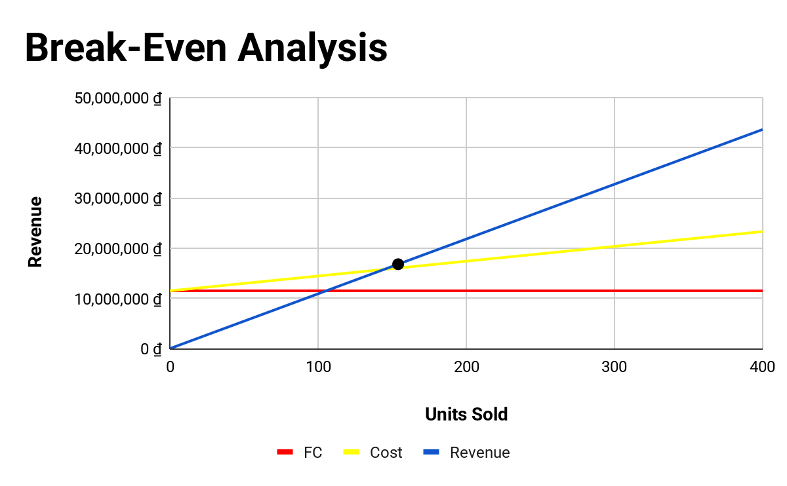
In the Break-Even Analysis chart:
- The slope of the revenue curve is determined by the average selling price per user, while the slope of the cost curve is determined by the variable cost per user.
- The revenue curve starts at 0 and increases linearly with the number of Premium users.
- The total cost curve starts at a fixed cost of VND 11,500,000 and increases according to the slope of the variable cost.
The intersection of these two lines is at approximately 154 users, which is the break-even point for the project.
After this point, as the number of users continues to grow, revenue will increase faster than costs, and the difference between the two will become the system's profit.

L. Investor Evaluation Criteria

Management Team Criteria

Personal and group experience
The project is being developed.Composed of 6 FPT University students majoring in Artificial Intelligence, Software Engineering, and Marketing. The team members have a background in Machine Learning, Deep Learning, Computer Vision, and UI/UX design.
The team has integrated herIntegrating AI (Computer Vision) into Minimum Viable Product (MVP) allowing for ingredient recognition and dish suggestions. The system can provide suggestions within 30 seconds, significantly reducing the time users spend thinking about menus, which averages 15–30 minutes per day.User survey.

Development strategy and plan
The team has developed a development roadmap consisting of three distinct phases:
- Phase 1 (January-April): Finalize the MVP and roll out beta testing with users.
- Phase 2 (January-October): Commercialization of the product through a subscription model.
- Phase 3 (2026-2030): Expand the AI ​​cooking assistant ecosystem and integrate it with IoT devices such as smart refrigerators.

Motivation and Vision
The project is driven by the goal of reducing food waste and simplifying daily cooking through AI. The team's long-term vision is to develop MealMate AI into the leading smart kitchen assistant in Vietnam.

Business & Deal Criteria

Business characteristics
MealMate AI is an early-stage technology startup with a lean organizational structure and a focus on developing AI-based products..

Development phase
The project is currently in the early-stage startup phase, transitioning from prototype to market validation, with the MVP already built and tested.

Business model
MealMate AI uses a SaaS (Software as a Service) model with a Freemium + Subscription strategy:
- Users can access basic recipes for free.
- Users pay to use advanced features such as:
  - AI meal planning
  - managing ingredients in the refrigerator
  - Keep track of food expiration dates.
Additionally, the project could expand its revenue through:
- partner with food retailers
- Affiliate program with a raw material sales platform.
- Food brand advertising.

Capital raising needs
The project is expected to raise 34,500,000 VND to:
- Run the product for 3 months
- Optimizing AI models
- maintain server system
- Implement a pilot marketing campaign.
The low capital requirement helps reduce risk for investors in the early stages.
- Initial development costs: ~108,000,000 VND
- Investors are requesting capital: 34,500,000 VND
For startups in the MVP stage, tunusualValuation ≈ 2-3 times development cost(because the product is already available and market research has been conducted).

Proposed results
Investment requested: 34,500,000 VND
Pre-money valuation: 200,000,000 VND
Post-money valuation: 234,500,000 VND

Investment request
The startup is seeking 34,500,000 VND in initial investment to support AI optimization, server infrastructure, and early-stage marketing activities.
Based on current development costs and the completion of the MVP, the project is estimated to have a pre-investment value of VND 200,000,000, resulting in a post-investment value of VND 234,500,000.

Product/Service Criteria

Product features
MealMate AI is hereAn AI cooking assistant allows users to take photos of ingredients in the refrigerator. The system will then:
- Identify the sourceComputer Vision
- Raw material data analysis
- Suggest suitable dishes in about 30 seconds.

The difference
Unlike traditional recipe apps, MealMate AI focuses on solving real-world user problems:
"What should I cook with the ingredients I have in the refrigerator?"

Technology used
System used:
- Computer Vision
- AI recommendation system
- The recipe database is optimized for ingredients commonly found in Vietnam.

Product status
- MVP is active.
- The ingredient scanning and recipe suggestion features have been implemented.

Financial criteria
Investors will assess profitability through the project's costs and revenue potential.

Expected profit
The project has a contribution margin of VND 75,15 per user, equivalent to a gross profit margin of approximately 68,9%, thanks to its SaaS model with low transaction costs.n low action.

Break-even point
The project reached the break-even point with 154 users.

Payback period
The initial investment can be recouped when the project reaches approximately 273 total users (equivalent to 164 Premium subscription payments), covering development costs within 12 months.

Market Criteria

Scale and growth potential
According to market research data:
- MarketThe global FoodTech market is projected to reach approximately $1.3 billion in 2024.
- It is projected to increase to $5 billion by 2035.
In VietnamIn the South, the F&B industry is growing at around 10% annually, while the application of AI in daily life is rapidly increasing.
Globally, according to MRFR and CAGR's report on AI in the Food Industry, the AI ​​Meal Planning - FoodTech sector is growing at 24-28% annually.
Another major opportunity is the development of smart home appliances, for example, the smart refrigerator that Samsung recently showcased at the Unpacked event on February 25, 2026, has the feature of recording items inside the refrigerator, and our technology will be a potential solution to integrate cooking suggestions with the items already inside. In addition, in the future, these devices will need a software platform to manage food and suggest meals, which will be one of the potential areas our product targets.

User research
A survey of 130 participants showed that:
- 93.8% of users are under 27 years old.
- 87.7% cook at home at least twice a week.
Many people encounter problems.The difficulty in deciding what to cook with the available ingredients creates a real need forProject solution.

Compete
MealMate AI adopts a Blue Ocean strategy, focusing on the AI-powered personal food management segment, where there are currently few direct competitors in Vietnam.

Investor Criteria
The project aims totheAngel investors or seed-stage investment fundsExperienced in the following areas:
- FoodTech
- SaaS
- AI applications.
The right investor not only provides capital but also offers support:
- strategic advisor
- retail partner connections
- Support for the next funding round.
In addition, the projectThe project is also suitable for investors interested inESG, especially in the followingReduce food waste and optimize food consumption in households.

